**International University of Business Agriculture and Technology**

**Lab report 06**

Name       : Abdullah Md Jahid Hassan.

Student ID: 20203020

Course     : CSC 440

Section     : A

Semister   : Fall 2022

Sl no     :

Mobile no : +8801756254873

E-mail       : hassan20203020@gmail.com



**Submitted to**

Rashedul Islam

Senior lecturer

Date: 18-09-2022

**01**

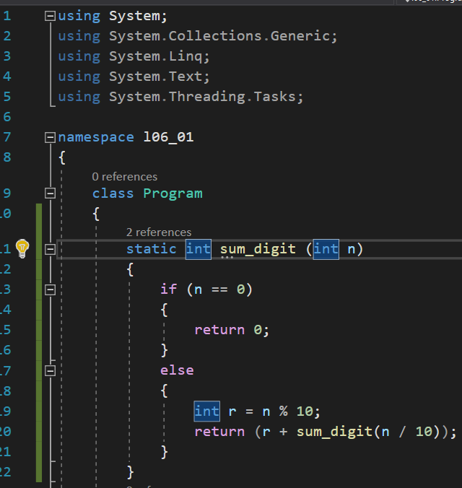

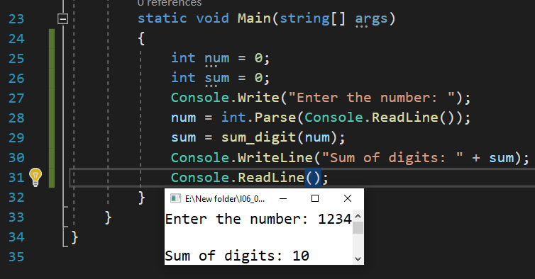

**02**

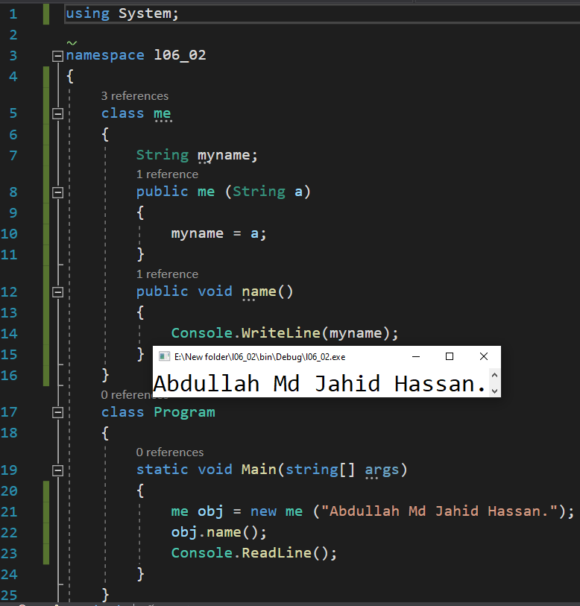

**03**

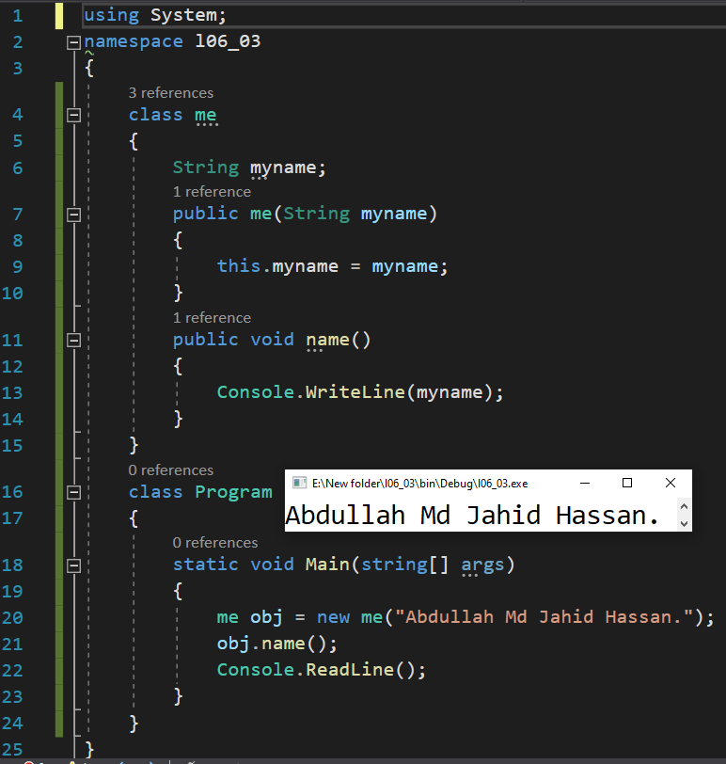

**04**

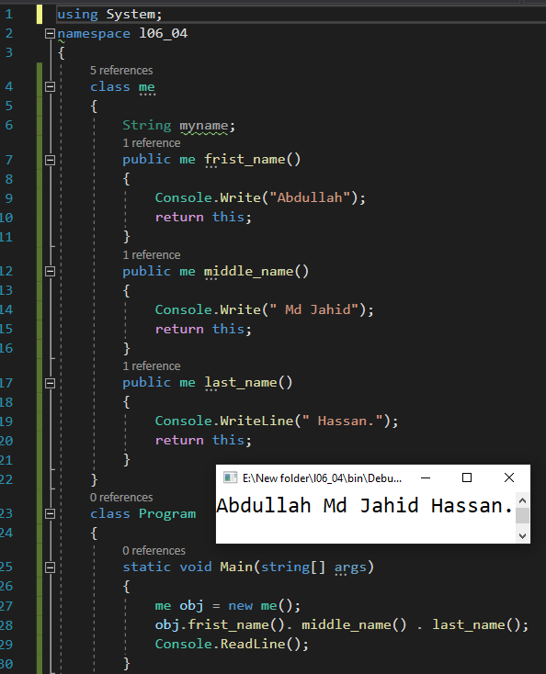

**05**

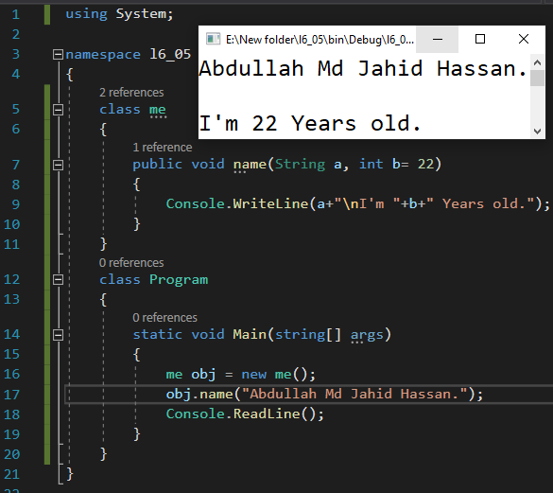

**06**

